### Implementing CRM For Result Tracking Of A Candidate With Internal Marks - (DEV)

**Creating Developer Org :**

* What exactly is Salesforce?

Salesforce is your customer success platform, and it is meant to assist you in selling, servicing, marketing, analyzing, and connecting with your customers. Salesforce provides everything you need to run your business from any location. You may manage relationships with prospects and customers, interact and engage with employees and partners, and securely store business data in the cloud using standard products and services.

* We must first go to developers.salesforce.com/ and click the sign up option in order to build a developer organization. then enter all the information.

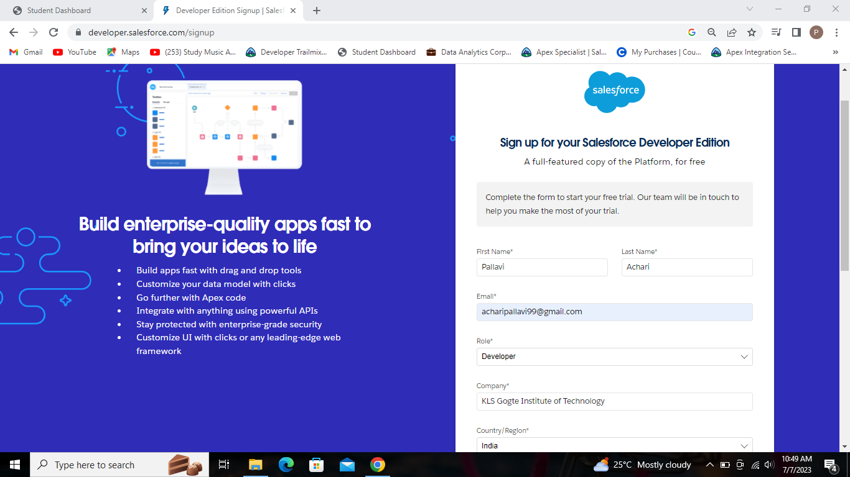

Sign up page for Developer Edition.

**Account Activation :**

* Visit the inbox of the email account you used to register. To activate your account, click the "verify account" button.

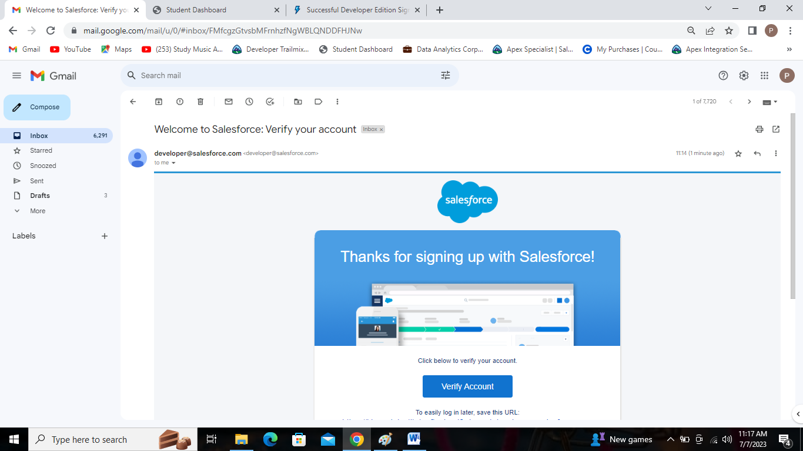

Account activation email.

**Login to Your Salesforce Account :**

* Login at salesforce.com by clicking the login button and enter your newly established username and password.

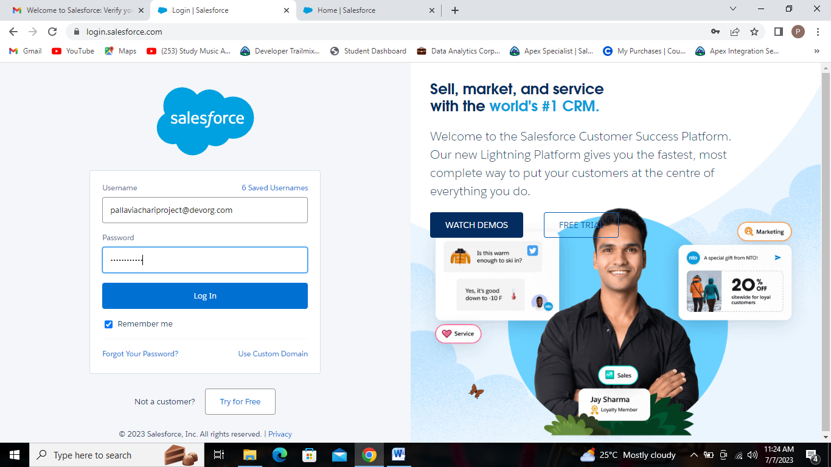

Login Page

* Following is the home page you will view after logging in.

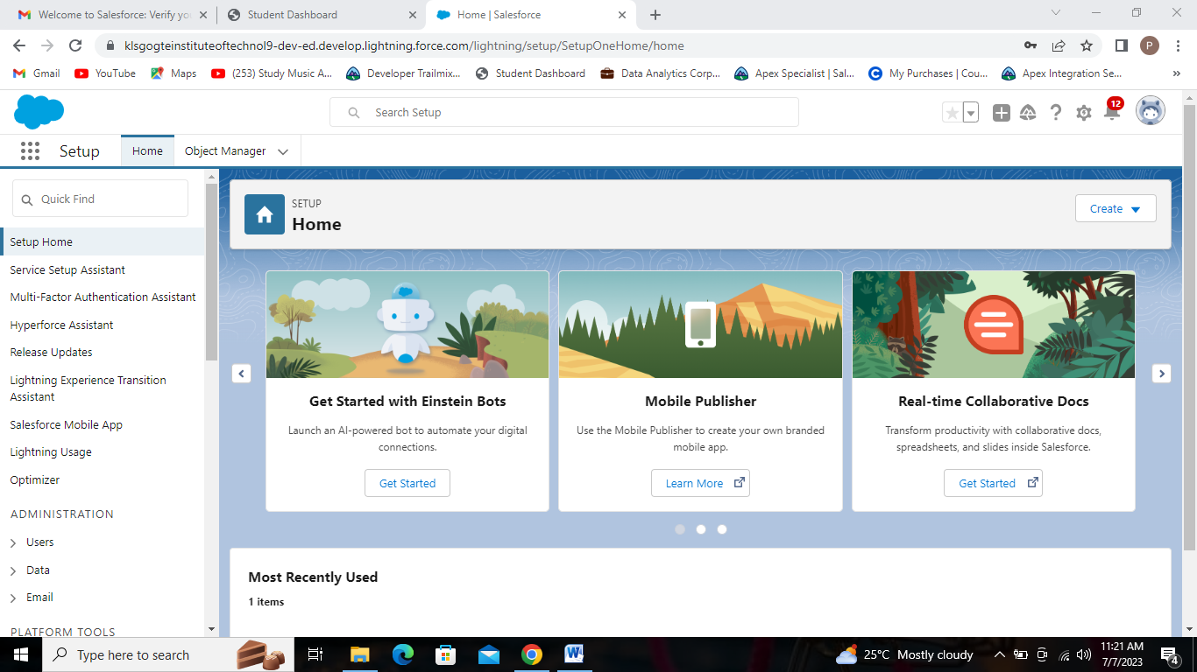

Home Page.